**GROUP 12: DEEP DROWSINESS DETECTION**

**Group Members:**

Kumud.( 101493945) Himani.( 101445554)

Erinda Kapllani(101495644) Bhumika Parvinkumar Shukla( 101389078)

**INTRODUCTION:**

Deep drowsiness is a serious problem for the drivers on our roads, causing many accidents and even deaths each year. This problem is compounded by various factors such as fatigue, alcohol consumption, monotonous road conditions, and driving during inappropriate times. Fatigue, in particular, impairs a driver's ability to react quickly to changing road conditions and increases the risk of accidents. Additionally, driving under the influence of alcohol or during late hours can exacerbate drowsiness and further compromise driver alertness. To address this issue, we are proposing to create and use a smart system called the Deep Drowsiness Detection System for Drivers. This system uses advanced technology like Artificial Intelligence (AI) and Machine Learning (ML) to recognize when a driver is starting to feel tired and might not be paying attention.

**PROBLEM STATEMENT:**

Driver drowsiness contributes to a high number of accidents, posing a significant risk to road safety.  This problem affects not only the driver but also passengers in the vehicle, as well as their families and loved ones who are impacted by potential accidents. The consequence of driver drowsiness can lead to accidents, injuries, and loss of life, causing emotional and financial distress for affected individuals and their families. To address this critical issue, we propose developing and implementing a Deep Drowsiness Detection System for Drivers. This system will use AI and ML technologies to detect early signs of fatigue, such as eye movements, expressions such as yawning and steering patterns, and alert drivers by high soundalarms to prevent potential accidents and ensure road safety.

**WHY THIS PROBLEM**

1. **Significant Impact**: Driver drowsiness contributes to a high number of accidents risking the lives of not only the driver but also to the co-passengers due to the driver's carelessness.
2. **Safety Innovation**: Developing a Deep Drowsiness Detection System showcases our commitment to innovative safety technology, setting us apart in the market.
3. **Competitive Edge:** Offering an advanced drowsiness detection solution gives us a competitive advantage, appealing to safety-conscious customers.

**LITERATURE REVIEW**

Several projects have explored efficient methods for detecting driver drowsiness, such as utilizing deep learning models or combining ECG, PPG, and HRV signals. However, these approaches have notable drawbacks. The deep learning-based method heavily depends on high-quality real-time video data, which can be challenging under varying lighting conditions or different face orientations. Additionally, using signals from wearable sensors like ECG and PPG may introduce noise due to slight movements, impacting the accuracy and reliability of drowsiness detection. Furthermore, both approaches require extensive training data to achieve high accuracy and face challenges in maintaining consistent performance across diverse driving conditions and driver behaviors.

**ML CANVAS**

**BUILDING ALGORITHMS:**

The basic thing about drowsiness detection is pretty simple. We first detect a face using dlib's frontal face detector. Once the face is detected , we try to detect the facial landmarks in the face using the dlib's landmark predictor. The landmark predictor returns 68 (x, y) coordinates representing different regions of the face, namely - mouth, left eyebrow, right eyebrow, right eye, left eye, nose and jaw. Ofcourse, we don't need all the landmarks, here we need to extract only the eye and the mouth region.

Now, after extraxting the landmarks we calculate the Eye Aspect Ratio (EAR).

The eye region is marked by 6 coordinates. These coordinates can be used to find whether the eye is open or closed if the value of EAR is checked with a certain threshold value.

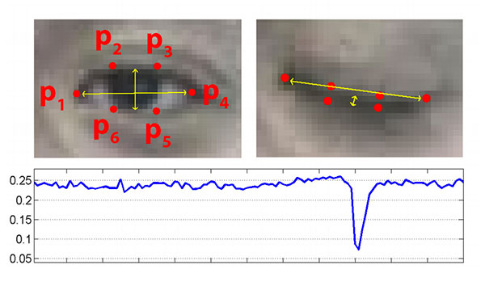

**DEPLOYMENT**

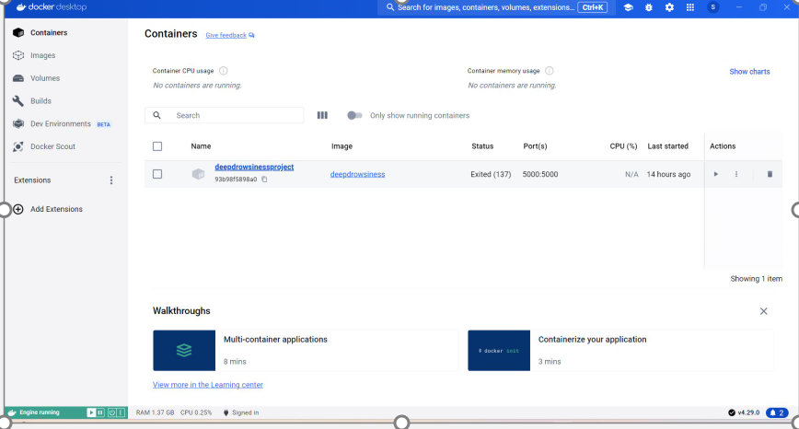

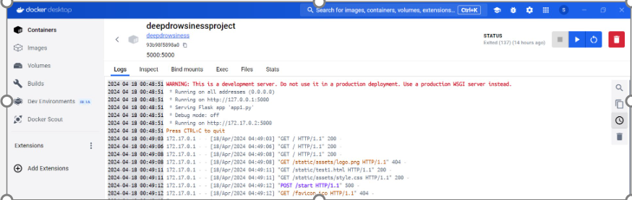

**CHALLENGES**

Dealing with dependency errors and conflicts in Python script development can cause debugging delays, impacting project timelines and productivity. Lengthy installation times for specific libraries can also slow down development iterations and experimentation. Additionally, complex Docker setup processes can introduce deployment environment setup challenges, leading to inefficiencies in collaboration and deployment workflows.

**CONCLUSION**

The Deep Drowsiness Detection System, utilizing AI and ML technologies, is designed to detect and address fatigue across various critical activities, extending beyond driving to industries like transportation, manufacturing, and healthcare. Future implementation ideas include integrating drowsiness detection into wearable devices, fostering partnerships with technology companies for real-time alerts. Additionally, exploring integration with smart infrastructure aims to enhance traffic safety. In education, adapting the system for classroom use could transform student support and engagement by providing real-time alerts to teachers and using drowsiness data to optimize teaching methods and assess student well-being.